**Mineral Processing Technology - Image Analytics**

K Sourabh Srivatsa

Keshav Memorial Institute of Technology, Hyderabad

# 

# 

# 

# 

# 

# 

# 

# 1. Table of Contents

**1. Table of Contents 2**

**2. Introduction: 3**

**3. Project Overview 4**

Project Scope 4

Tech Stack 4

**4. Installation 6**

System Requirements: 6

Software Requirements 6

Installing Software 6

**5. Usage 9**

**6. Data Sources 11**

**7. Image Analytics Algorithms 12**

Image Preprocessing 12

Geometric and Spatial Analysis 12

Output and Storage 13

**8. Results and Interpretations 14**

Input Images 14

Output Images 15

**9. References 16**

**10. Appendix 17**

Input Images 17

Output Images 18

Image 1 18

Image 2 19

Image 3 20

Image 4 22

Image 5 23

**11. Acknowledgements 24**

# 

# 

# 

# 2. Introduction:

In the field of Mineral Processing Technology, the accurate analysis of mineral particles is of paramount importance. This analysis aids in the determination of mineral quality, entropy values, and the establishment of the degree of liberation of valuable minerals from the gangue at various particle sizes. To address these critical aspects, this project focuses on developing a Mineral Particle Analysis System using image analytics. By applying advanced image processing techniques, the system will extract vital information from mineral particle images, helping researchers and professionals in mineral processing make more informed decisions.

The primary objectives of this project are to analyze mineral particles from an input folder and provide essential measurements and data for each particle. This includes:

1. The Smallest Encapsulating Circle
2. Total Surface Area
3. Total Perimeter
4. The Major Axis
5. Centroid Location

# 3. Project Overview

The project, titled "Mineral Particle Analysis System," aims to automate the analysis of mineral particles in digital images. It will address the following key tasks for each mineral particle in the input dataset:

1. **The Smallest Encapsulating Circle:** The system will generate a minimal circle that entirely encompasses the particle within the image. This circle will provide insight into the particle's overall size and shape.
2. **Total Surface Area:** The system will calculate the total surface area of the mineral particle in pixels. This information is crucial for assessing the particle's spatial characteristics.
3. **The Major Axis:** The project will identify and measure the longest axis entirely contained within the particle. This measurement aids in determining the particle's orientation and elongation.
4. **Total Perimeter:** The system will calculate the total perimeter of the mineral particle in pixels. Perimeter information is valuable for characterizing the particle's contour.
5. **Centroid Location:** The centroid of the mineral particle will be determined. The centroid is a vital feature for understanding the particle's spatial distribution and balance.

## Project Scope

This project leverages advanced image processing and analysis techniques to ensure accurate and consistent measurements for each mineral particle, contributing to a deeper understanding of mineral properties in the field of mineral processing technology.

The Mineral Particle Analysis System is designed to be a versatile and user-friendly tool that can handle a wide range of input images. The data generated by the system will enable researchers and mineral processing experts to make informed decisions regarding mineral quality and liberation from the gangue at various particle sizes. This project's outcomes will provide a valuable resource for enhancing mineral processing practices and optimizing mineral recovery processes.

## Tech Stack

The development of the Mineral Particle Analysis System relies on a combination of programming languages and libraries to ensure accurate and efficient image processing. The primary technologies used in this project are as follows:

**Python 3.11.6:**

Python serves as the core programming language for this project. It is renowned for its versatility and extensive library support, making it an ideal choice for image analysis and processing.

The following libraries/modules of Python 3.11.6 are used:

1. **OpenCV (Open Source Computer Vision Library):**

OpenCV is a powerful open-source computer vision library that provides a wide range of tools and functions for image processing and computer vision applications. In this project, the following OpenCV components are utilized:

* **Opencv-python:** The primary OpenCV package used for image processing tasks.
* **Opencv-python-headless:** A headless version of OpenCV that is useful for systems without graphical interfaces.

1. **NumPy:**

NumPy is a fundamental library for numerical and scientific computing in Python. It is used for efficient array processing and mathematical operations, making it an essential component for handling image data in this project.

1. **Pillow (PIL Fork):**

Pillow is a Python Imaging Library (PIL) fork that is used for opening, manipulating, and saving various image file formats. It plays a crucial role in image loading and preprocessing within the Mineral Particle Analysis System.

These technologies collectively enable the project to extract, process, and analyze digital images of mineral particles efficiently. Python serves as the programming backbone, while OpenCV, NumPy, and Pillow contribute the necessary image processing and manipulation capabilities. The combination of these technologies empowers the system to fulfill the objectives outlined in the project, providing valuable insights into mineral particle characteristics for the field of Mineral Processing Technology.

# 

# 4. Installation

The Mineral Particle Analysis System is designed to be lightweight and should run smoothly on a wide range of computer systems. To get started with the installation, please follow the steps below:

## System Requirements:

The project is lightweight and should run on low-spec computers, meeting the following basic system requirements:

1. A computer with an operating system (Windows, macOS, or Linux).
2. Adequate storage space for the project files.
3. Prerequisites:

## Software Requirements

1) Python 3.11.6

**Python Libraries:**

1) Opencv-python

2) Opencv-python-headless

3) Numpy

4) Pillow

### Installing Software

Python Installation

If Python is not already installed, you will need to install it. We recommend using Python 3.11.6.

You can download Python from the official website: Python Downloads.

Installing Python Libraries

Open a command prompt or terminal window.

**Opencv-python and Opencv-python-headless:**

Enter the following commands in your Terminalr to install the required OpenCV libraries:

> pip install opencv-python

> pip install opencv-python-headless

**Numpy:**

Install the NumPy library using the following command:

> pip install numpy

**Pillow:**

Install the Pillow library with this command:

> pip install Pillow

Testing the Installation

To verify that the Mineral Particle Analysis System is correctly installed, you can run a simple test script. Create a Python script (e.g., test_system.py) with the following content:

import cv2

import numpy as np

from PIL import Image

print("Installation successful!")

print("OpenCV version:", cv2.__version__)

print("NumPy version:", np.__version__)

print("Pillow version:", Image.__version__)

Save the script and run it using Python:

> python test_system.py

If the installation is successful, you should see information about the installed libraries and a "Installation successful!" message.

# 5. Usage

The Mineral Particle Analysis System is designed for ease of use and automation. Follow the steps below to execute the system and analyze mineral particles in your input images. Please note that this guide assumes you have successfully completed the installation steps outlined in the "Installation" section of this documentation.

1. **Running the Main Script:**

To execute the Mineral Particle Analysis System, you will use the provided `main.py` script. This script orchestrates the analysis of mineral particles in your input images and generates output images. Follow these steps:

1. **Locate the "main.py" Script:**

Go to the "code" folder within your project directory.

1. **Copy the Path to "main.py":**

Right-click on "main.py" and select "Copy as path."

1. **Execute the Script in Command Prompt/Terminal:**

Open a command prompt (Windows) or a terminal (macOS and Linux).

In the command prompt or terminal, enter the following command, replacing `<insert_copied_path>` with the path you copied in step b:

python "<insert_copied_path>"

Press Enter to run the script. The system will process the input images, perform the desired measurements, and generate the output images.

1. **Wait for Completion:**

The system will process the images, and you should see progress messages in the command prompt or terminal. Wait for the process to complete.

1. **Checking Output:**

The output images are stored in various folders based on the type of measurement, and the system creates separate folders for each measurement attribute. To inspect specific results for an input image, follow these guidelines:

Centroid

To examine the centroid of a specific input image (e.g., "img_1"), navigate to the "Centroid" folder and open "output_image 1."

Total Surface Area

If you want to inspect the total surface area of a particular input image (e.g., "img_4"), locate the "Total Surface Area" folder and open "output_image 4."

Repeat the above pattern for any other measurement output you want to check. Each measurement attribute corresponds to a separate folder, and within each folder, you can find the output images named according to the input image they pertain to.

By following these steps, you can efficiently execute the Mineral Particle Analysis System, process your input images, and access the output images that contain valuable information about the analyzed mineral particles.

# 6. Data Sources

The Mineral Particle Analysis System project, relies on specific data sources for its operation and analysis. Understanding these data sources is crucial for users to process and analyze mineral particles accurately. The project utilizes the following data sources:

1. **Input Images:**

A set of input images are provided as part of the project. These input images contain mineral particles that need to be analyzed.

The input images are essential for conducting image processing and analysis to extract measurements and attributes of the mineral particles.

1. **Background Removed Images:**

During the preprocessing phase, the project automatically removes the background from the input images and inverts their colors to enhance the visibility of mineral particles.

These background-removed and color-inverted images are temporarily stored in a folder named "cutdown."

It's important to note that the "cutdown" folder is a temporary storage location and is automatically deleted after the main analysis process is complete. These data sources, combined with the automated preprocessing step, are the foundation of the Mineral Particle Analysis System and facilitate the accurate analysis of mineral particles from the provided input images.

# 7. Image Analytics Algorithms

In the context of our project on Mineral Processing Technology, we employed a tailored set of image analytics algorithms to extract essential information from mineral sample images. These algorithms, implemented using Python 3.11.6, focused on image preprocessing, overlay addition, and the extraction of key geometric and spatial properties from the images using the NumPy, OpenCV, OpenCV-Headless, Pillow (PIL), and os libraries.

## Image Preprocessing

1. Background Removal with Rembg:Our image processing pipeline began with the use of the Rembg library, which effectively removed background elements from the input images. This step was crucial to isolate the mineral samples from any extraneous elements in the images, ensuring the subsequent analysis focused exclusively on the mineral phases.
2. Overlay Addition with Pillow (PIL): After background removal, we employed Pillow (PIL) to add overlays and enhance the visual representation of critical features and measurements.

## Geometric and Spatial Analysis

OpenCV and OpenCV-Headless Libraries: The core of our image analytics process involved the use of the OpenCV and OpenCV-Headless libraries to perform geometric and spatial analysis on the preprocessed images. This analysis included the following key aspects:

Centroid: The centroid of each mineral phase was determined, representing the geometric center of the object. This information is valuable for understanding the spatial distribution of minerals in the sample.

Major Axis: The major axis of each mineral phase was calculated, providing insights into the orientation and elongation of the mineral objects.

Perimeter: The perimeter of mineral phases was measured, offering data on the boundary length, which is essential for characterizing irregularly shaped minerals.

Smallest Encapsulating Circle: A circle with the smallest possible radius that encompasses each mineral phase was computed. This encapsulating circle is a fundamental geometric feature for further analysis.

Total Surface Area: The total surface area covered by each mineral phase was estimated, enabling the quantification of the mineral distribution within the sample.

## Output and Storage

Output Folder: The results of the image analysis, including the calculated centroids, major axes, perimeters, smallest encapsulating circles, and total surface areas, were saved in an output folder for reference and further analysis. The organized storage of these metrics facilitated easy access and retrieval.

In conclusion, the Image Analytics Algorithms section showcases the step-by-step processes and techniques applied to mineral sample images. By combining background removal, overlay addition, and advanced geometric and spatial analysis, our project effectively extracted and quantified essential mineral characteristics, contributing to a more comprehensive understanding of mineral composition and distribution in the context of mineral processing technology.

# 8. Results and Interpretations

## Input Images

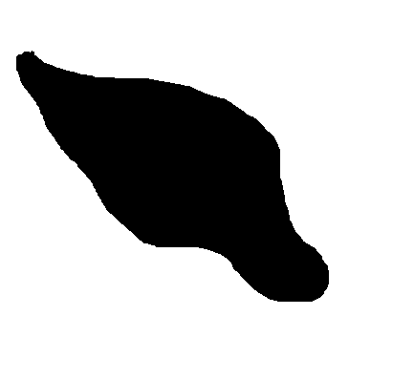





## Output Images

1. Go to the folder “output” and check the output images based on the attribute of the image that is required

**NOTE:** All of the output images are in the Appendix Section of the Documentation Report

# 9. References

In the development of the Mineral Particle Analysis System, various resources were consulted to acquire knowledge, guidance, and support. The following references were instrumental in shaping the project:

1. **Stack Overflow:**

Link: <https://stackoverflow.com/>

The Stack Overflow community provided valuable solutions to technical challenges, code examples, and insights into image processing and Python programming. Numerous discussions on image analysis and OpenCV were referenced during the project's development.

1. **ChatGPT (GPT3.5):** Conversations and guidance from the ChatGPT (GPT3.5) model, developed by OpenAI, were instrumental in addressing technical questions and offering general assistance throughout the project's development.
2. **GeeksforGeeks:**

Link: <https://www.geeksforgeeks.org/opencv-python-tutorial/>

The GeeksforGeeks website served as a valuable resource for tutorials, code samples, and explanations related to various programming and image processing topics. It provided insights into Python, OpenCV, and other relevant libraries.

1. **OpenCV Official Documentation:**

Link: <https://opencv.org/>

The official OpenCV documentation was referred to extensively for detailed information on OpenCV functions, modules, and best practices in computer vision and image processing. It provided a wealth of technical knowledge and guidance.

These references played a crucial role in the successful completion of the Mineral Particle Analysis System project, providing technical insights, solutions to challenges, and a deeper understanding of image analysis and computer vision concepts.

Thdnthd

# 10. Appendix

## Input Images

## 







## Output Images

Images not to scale, check the output folder for the actual output image

### **Image 1**

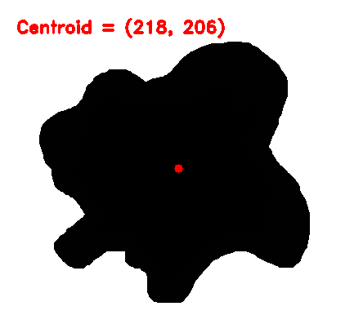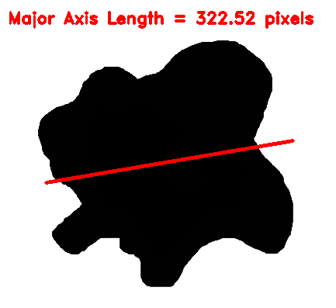

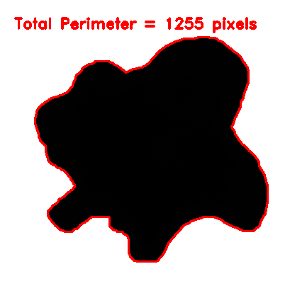

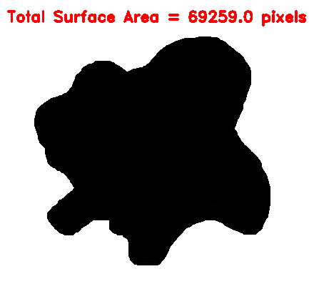

### **Image 2**

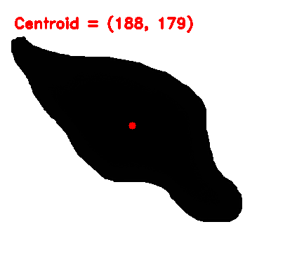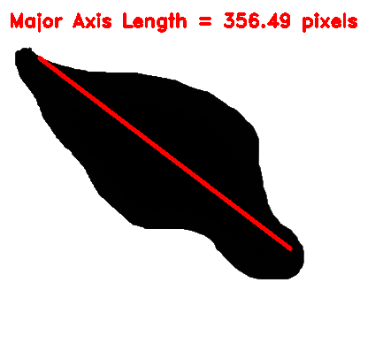

\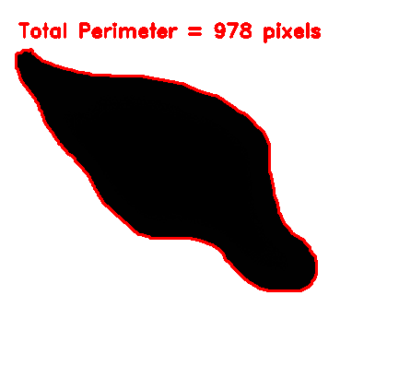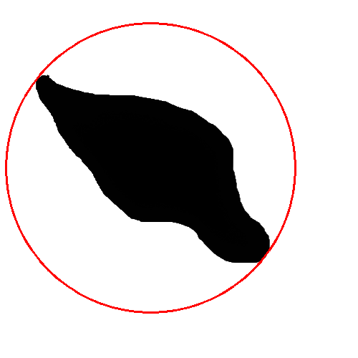

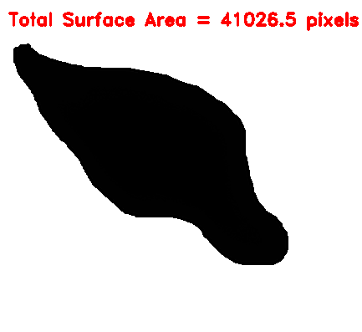

### **Image 3**

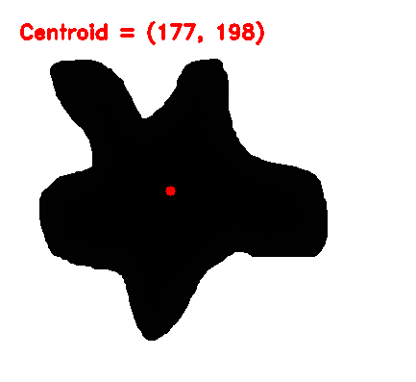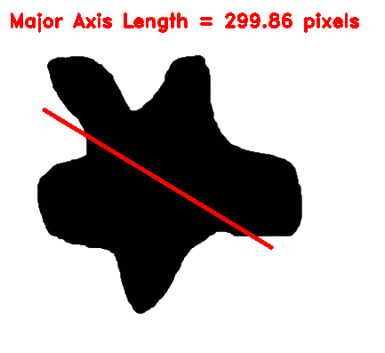

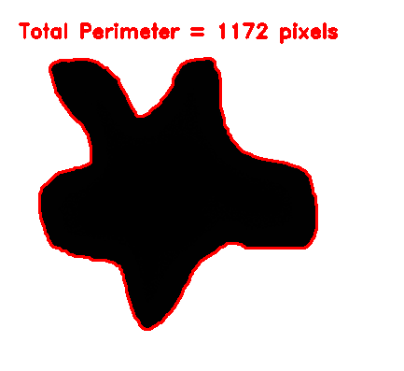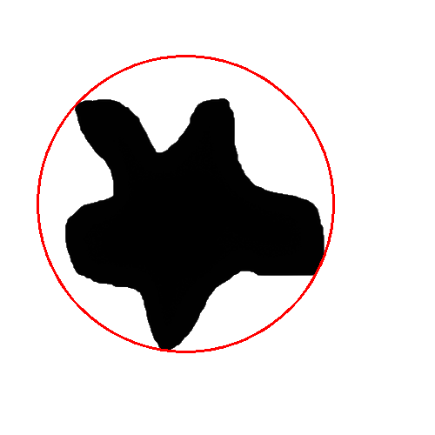

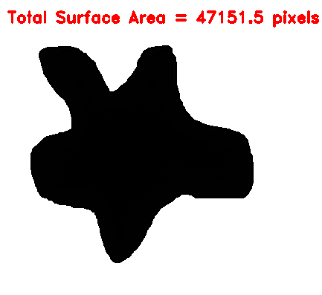

### **Image 4**

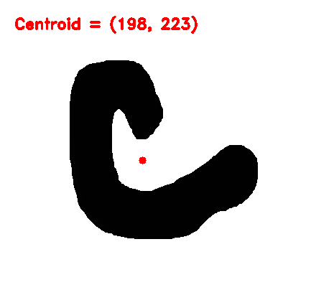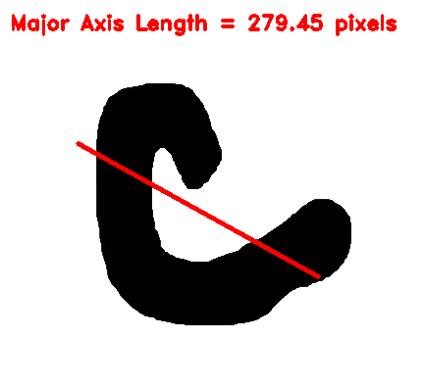

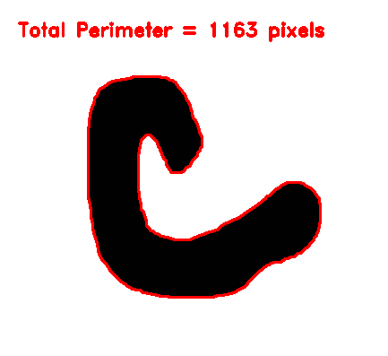

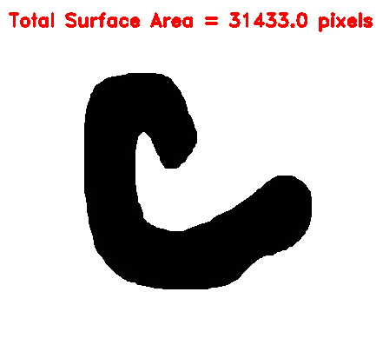

### **Image 5**

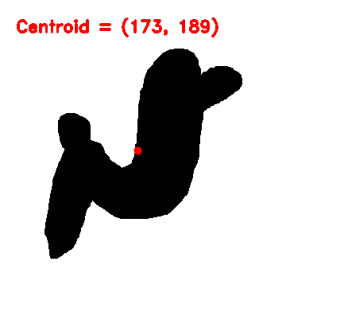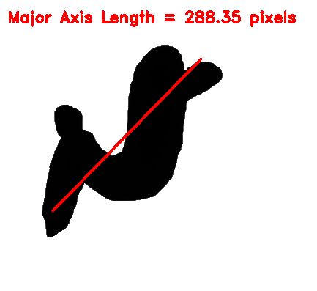

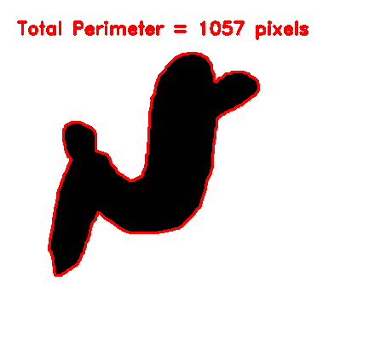

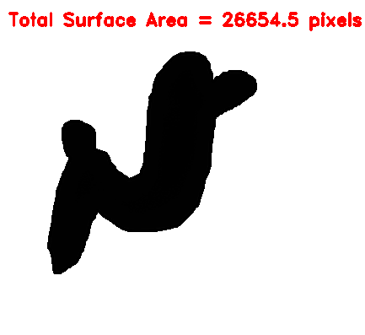

# 11. Acknowledgements

I would like to express my sincere gratitude to CognidaAI for providing the valuable image data for this project, "Mineral Processing Technology - Image Analytics."

I am deeply thankful to my professors for their guidance and support throughout this project.

My appreciation goes to the online resources and research papers that enriched my understanding of this field.

This project's success is a result of the collective support and contributions from these individuals and organizations.